ESB Lab

1. Before we install the ESB we need to host some services to interact with. To do this we are going to install the WSO2 Application Server. Unzip the wso2as-5.0.1.zip file:  
     
   cd ~/oxsoa  
   unzip ~/Desktop/wso2as-5.0.1.zip
2. Make sure the scripts are executable:  
   cd wso2as-4.5.1  
   chmod +x bin/*.sh
3. Start up the server:  
   bin/wso2server.sh
4. In Chrome, browse to   
   [http**s**://localhost:9443](https://localhost:9443) [Note the SSL URL]  
     
   You will get a message like this: 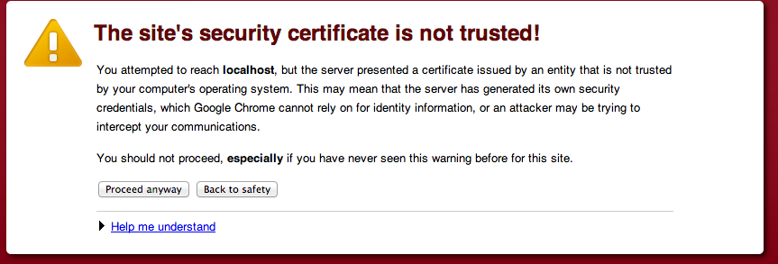  
   This is because we haven’t installed a “proper” certificate into the server. Click **Proceed Anyway**
5. Use **admin/admin** as username and password. Click **Remember Me** and sign in:   
   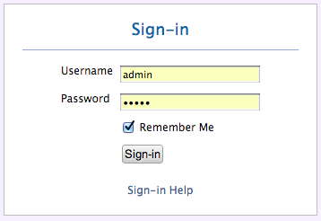
6. You should see a Web Console like this: 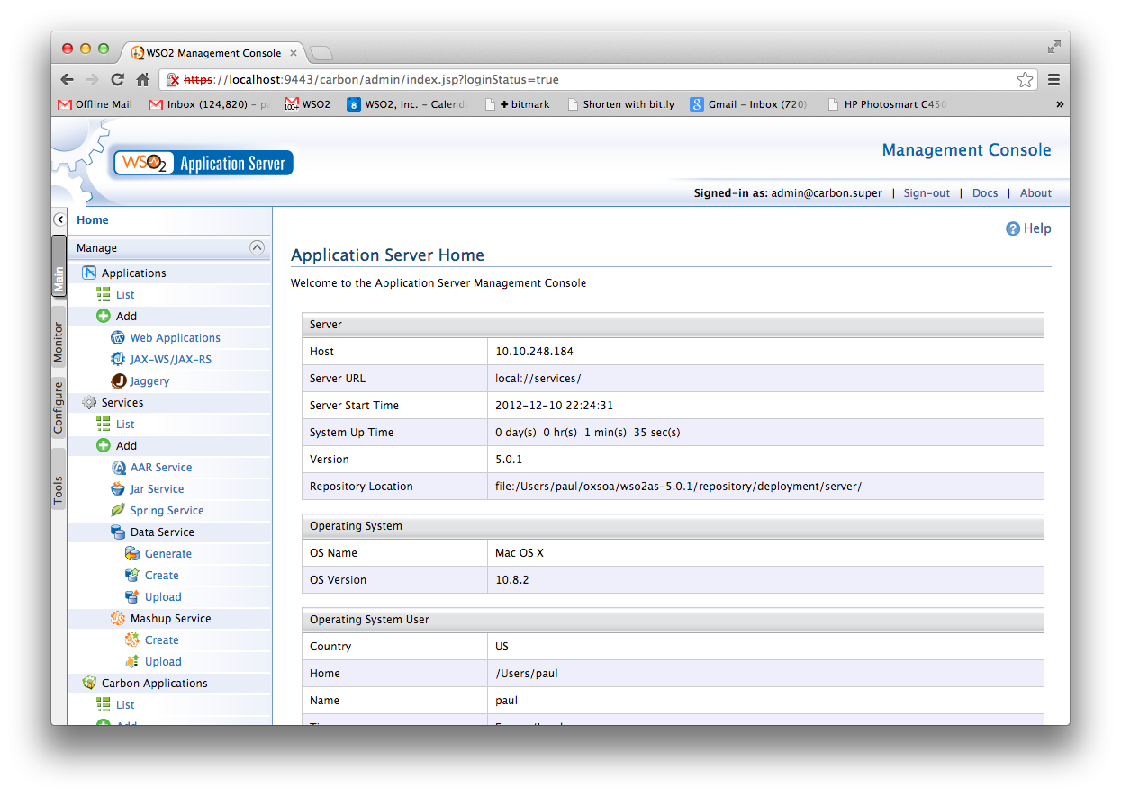
7. Click on **Services->List** in the left hand menu. You should see something like this: 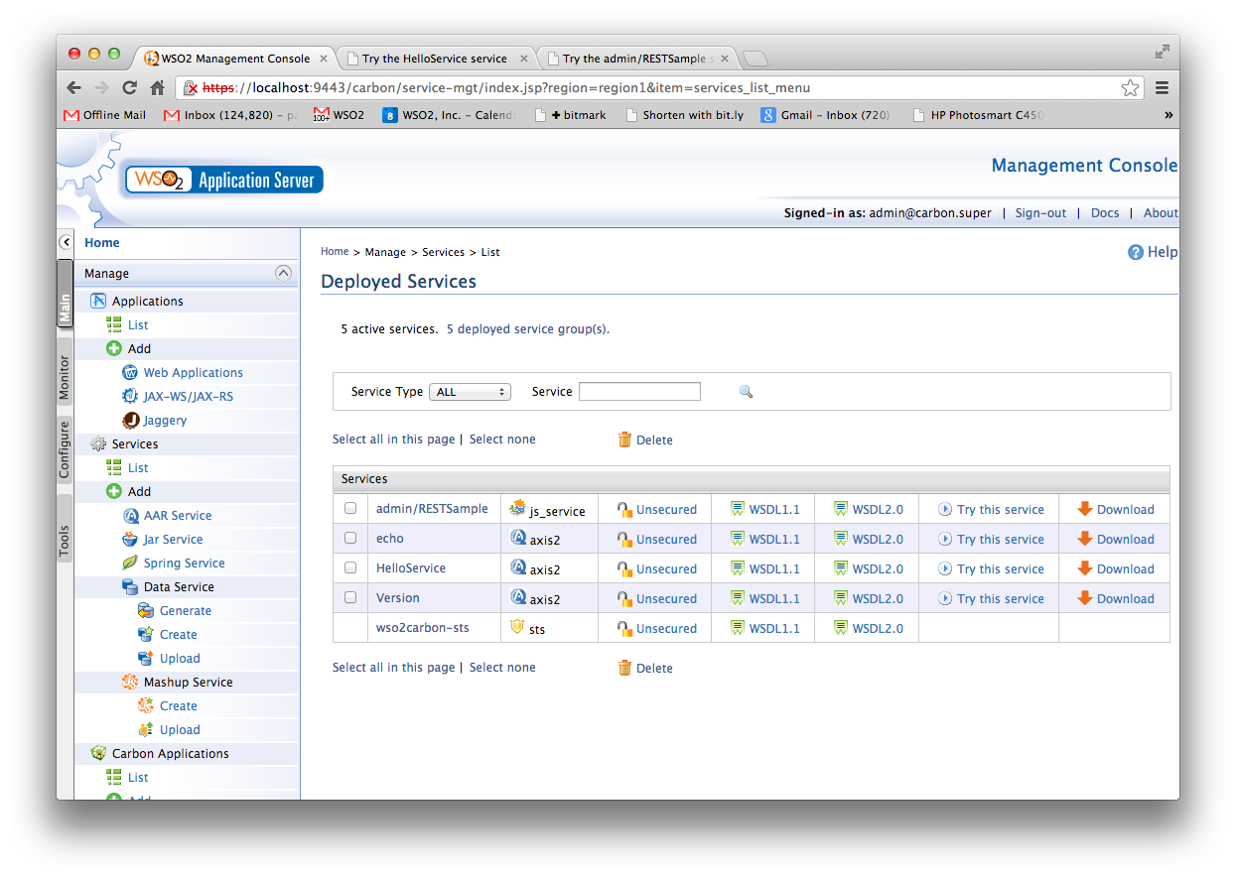
8. To see if the basic “echo” service is working click on “Try this service” next to echo.
9. You will see a “test” client. 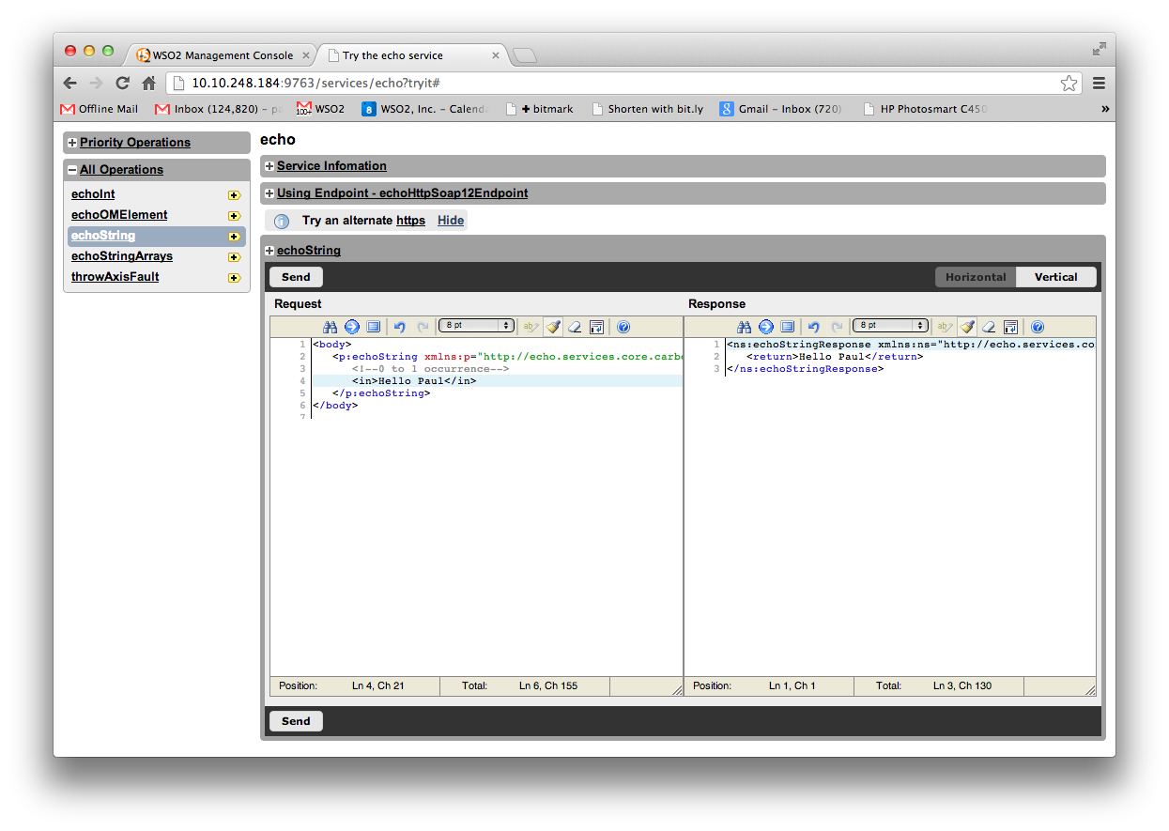
10. Select the **echoString** operation, modify the XML **(replace the ?)** and click **Send**. If it didn’t work, you might have an odd network setup with VMWare. Try changing the URL to use 127.0.0.1.
11. Close that tab to get back to the main console.
12. Download the Starbucks Outlet Service:  
    Browse to <http://freo.me/UtN4Mj>
13. Click on **Services/Add/AAR Service.**
14. Click on **Choose File**. Browse to the saved StarbucksOutletService.aar   
    This is an Axis2 Web Service application. Click **Upload**
15. Wait a minute for this to deploy, then Click on **Services/List** again.
16. Now Click on **Try this service** for the StarbucksOutletService.
17. Create an order, list orders, pay for it, etc. Get a feel for the SOAP API.
18. Go to the Monitor tab and look at some stats, logs, etc.
19. **INSTALLING THE ESB**

Start a new command line window

1. Unzip and install the WSO2 ESB:  
     
   cd ~/oxsoa  
   unzip ~/Desktop/wso2esb-4.5.1.zip
2. Make sure the scripts are executable:  
   cd wso2esb-4.5.1  
   chmod +x bin/*.sh
3. Before starting the server, we have to cure a problem. The ESB and App Server both will want to bind to the same network ports, which is not allowed.
4. Luckily there is an easy fix. Edit the   
   ~/oxsoa/wso2esb-4.5.1/repository/conf/carbon.xml   
   config file
5. Search for offset and change the entry to read:  
     
   <Offset>1</Offset>
6. This will move all the ports up by 1.
7. Start the server up  
   bin/wso2server.sh
8. In Chrome, browse to   
   [http**s**://localhost:9444](https://localhost:9444) [Note the SSL URL]

1. Login as before. You should see a similar (but different) console. Compare to the App Server screens. 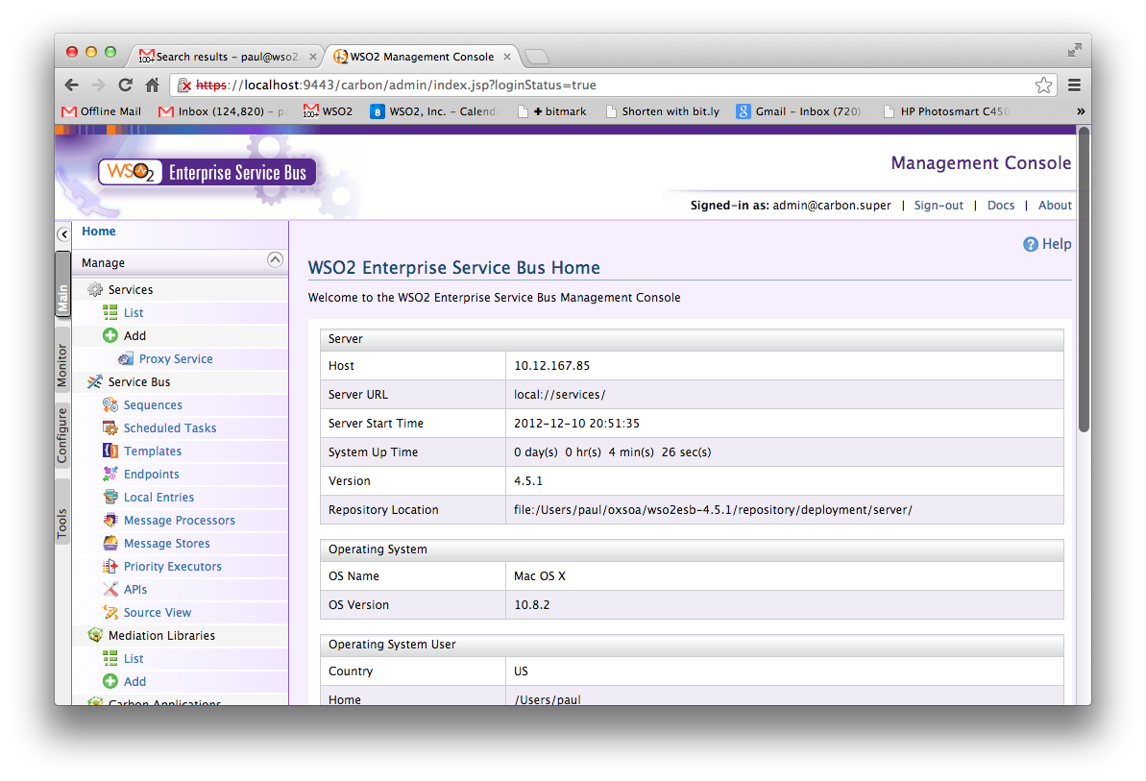

1. Later
2. Download the Starbucks ESB config:
3. Unzip the ESB configs into the right place:  
     
   On the command line:  
   cd ~/oxsoa/wso2esb-4.5.1  
   cd repository/deployment/server  
   unzip ~/Downloads/synapse-configs.zip  
     
   When prompted:  
   replace synapse-configs/default/synapse.xml? [y]es, [n]o, [A]ll, [N]one, [r]ename:  
   **Type A and hit Enter**
4. Look at the ESB command line window and see how the progress is going.